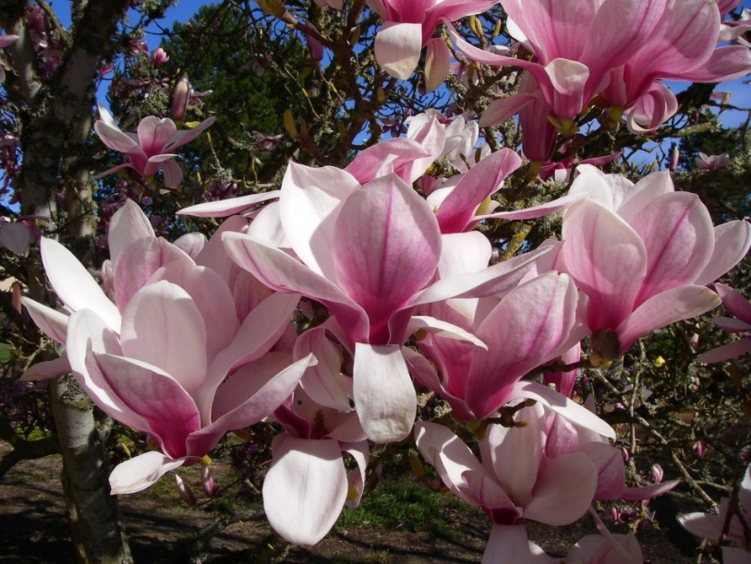
Since these are seedlings of a hybrid plant, each one will be slightly different. They will vary by color (how white or pink the flowers are each spring), as well as by how tall the plant gets when mature. These magnolias are shorter than 30’ tall and are considered a small tree. Their “mother” ‘Winelight’ is also very fragrant, so likely these seedlings will be as well.
Other common names they are known by: Tulip Magnolia, Japanese Magnolia, Saucer Magnolia, Star Magnolia, Loebner Hybrid Magnolias, and the ‘Little Girls’ series.

Culture and Care
Where to plant?
- Exposure: These plants will grow in full sun but will appreciate some afternoon shade, or very light shade in our scorching summers.
- Watering: Magnolias like water, so avoid very dry spots, or places where you cannot water the plants occasionally. They do not need to be pampered, but a regular weekly watering of 1-2 gallons per plant, for 4-6 weeks after you plant them at home is best.
Care & Maintenance.
- Fertilizing: They really don’t need fertilizer and are adapted to growing in Florida soils, so if you want to you can fertilize with any general tree and shrub fertilizer. Best to fertilize in spring after they flower.
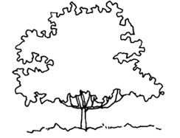
- Pruning: Many of these trees just like to grow straight up, which is fine except that means all the flowers are way up high and it is harder to enjoy them. When a plant is growing too tall, feel free to cut the upright branch tips off and encourage more side branching. Pruning the tree to shape the branch structure is best done in the first years after planting, as the plants age the growth rate slows and it takes longer for major pruning cuts to heal. Prune in spring right after flowering.
History etc.
- Origin: Southern China and Japan. They were hybridized extensively before even coming to the USA. Because the climate in China and parts of Japan can be similar to the Southeastern USA they were discovered to thrive here and American plant breeders began of grow them.
- These plants were created by Dr. Todd Gresham in Santa Cruz California, but Todd soon learned they performed much better in the south, so he moved most of his work to Louisiana and Alabama. Much of his original breeding can still be seen at Dodd Nurseries in Mobile, Alabama.
- Problems with late frosts: Here in North Central Florida, the last frosts of the year almost always do damage to the emerging buds (Tulip Magnolias usually bloom before azaleas and dogwoods), but the plant always comes back and when they have a good year, you will enjoy the most amazing masses of sweet, fragrant flowers and pink shaded beauty. It will all be worth it!

