Sensory Gardens

What is a sensory garden?

Sensory gardens provide intimate spaces where young children can be immersed in the scents, textures and colors of plants and related elements. Along with specially selected plants, sensory gardens may also include elements such as wind chimes, wind socks, flags, and children’s art. Two popular forms of sensory gardens are sensory pathways and keyhole gardens.

Sensory pathways

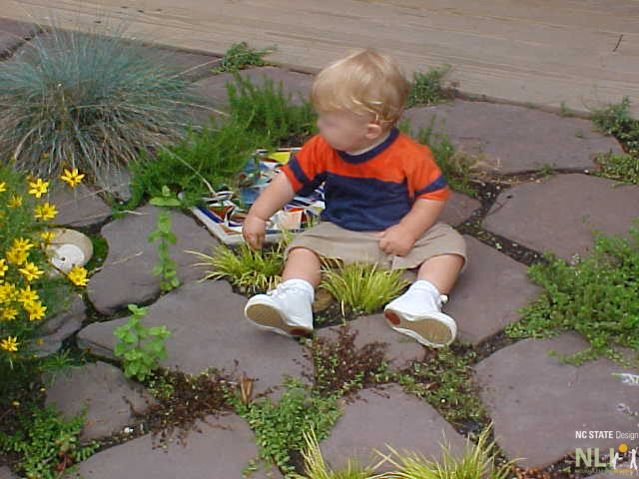
Sensory pathways can be constructed of smooth, flat, stepping stones or tree cookies with gaps wide enough for in-between planting. Stepping stones can be natural stone or concrete or made by children to include hand prints, leaf prints, shells, marbles, colored tile mosaics, or smooth glass. Glass blocks or clay bricks can be laid in the sensory pathway to add additional sensory richness and variety. Sensory pathways should be considered part of the larger pathway system and should not dead end. They can be installed as a narrow (18″-24″), short loop off the primary pathway (Figure 1) or a broad (36″-72″) connection between settings (Figure 2).
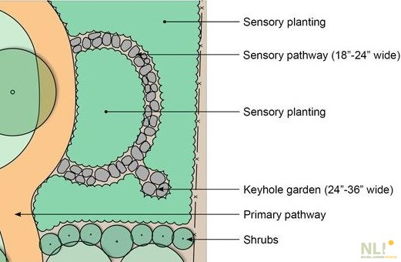
Figure 1: Sensory pathway as a short loop off primary pathway. Keyhole garden added along sensory pathway.

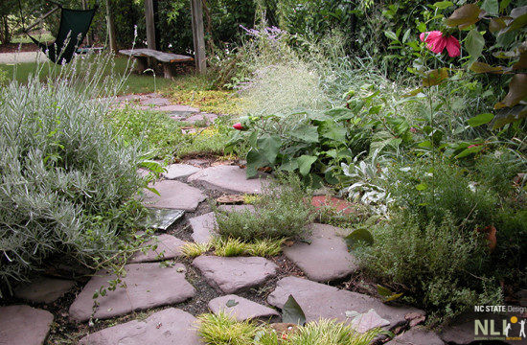
Figure 2. This wide, sensory pathway connects the classroom porch to a vine-covered pergola.

Keyhole gardens

Keyhole gardens provide an intimate space to rest while immersed in sensory plants. Keyhole gardens are shaped like a skeleton keyhole with a narrow entry and bulbous, interior space wide enough for a young child or two to sit and reach the plantings on either side (approximately 24” – 36” wide). Keyhole gardens can be installed as a subspace along a sensory path or be designed as a stand-alone setting.

Choosing the right space
A sensory garden can be everything from a window box to a huge area. Even though it depends how much space a school has, there's always a space in the school you can make into a more sensory environment.
The shape and size of the garden is determined by what the school wants to use the space for. It also depends what students you have. For example, if you don't have any children in a wheelchair, you can have tighter corners and more slopes. If you do need to consider wheelchair access, then you’ll want to keep your lines simpler.

What to include in your sensory garden

Sensory plantings

Sensory plantings should be hardy, vary in height, color, texture and scent, provide year-round sensory interest, and be planted within easy reach. Perennials, ground covers, ornamental grasses, small shrubs and edible plants can be incorporated.
Sight
The visual impact of the space is the most important element. Recommended mantra for schools is green, green and more green.
Raised planters are great for schools because it cuts down on maintenance and means you don't have to hack out the ground. Trellis work is also well because you can grow climbers up it. It also provides privacy for the children in the garden. (Chain link fences are also a great method of supporting vining or climbing plants.) The biggest impact, however, will be from the trees, which should always be evergreen so children can use the garden all year round. Even if space is limited, have one or two key/feature trees that provide shade, shelter, and an overall sense of “I am protected here” is important to immersing a child in a garden. If this isn’t possible, consider a gazebo or arbor trellis with integrated bench where cover vines can be grown.
Plants for Sight

Sight is mainly color, movement and shape of foliage and flowers. Try to include plants like Eucalyptus Gunii or salix trees which provide both color and movement.
Touch
Every single plant has a different feeling – wide, narrow, elliptical, oval or hairy. Touch can also be covered using ground surfaces such as mosaics, pebbles, gravel, polished glass pieces and shingles. Consider using timber – rough, smooth, grooved – in pathways or decking. There are plenty of stone materials including bricks and pavers which feel great to touch under foot or hand.
Plants for Touch

Make a list of the plants that are interesting to touch, maybe choose plants such as Euonymus alatus for its corky bark, Betula jaquemontii for the main stem, Stachys ‘Silver Carpet’ for its leaves, Cape Jasmine, Cockscomb, Feather grass, Gay-feather, Globe Amaranth, Hare's Tale Grass, Lamb's ears, Lily, Love-lies-bleeding, Mullein, Obedient Plant, Poppy, Pussy willow, Rose mallow, Squirrel-tail grass, Statice, Woolly thyme, Wormwood.

Smell
Choose flowers that are highly scented or shrubs such as the Mexican orange blossom which, when you rub the leaves, gives out a fragrant, aromatic scent. Timber smells great when it dries out too. Shrubs, flowers, herbs, leaves – these can all give off a wonderful scent. Lavender and rosemary are two classic plants for this purpose.
Plants for Scent

When you select your sensory garden plants for smell, also choose some for the different ways they release scent:
- Scents that fill the air and can be smelt without touching the plant like Mock orange, Philadelphus, some roses, Honeysuckle, and the Curry plant.
- Plants you will need to get up close to too smell, Violet, primrose and some Narcissus.
- Plants you will need to pinch or crush in your hand to smell, like Peppermint, Apple mint, Lemon thyme most culinary herbs, Camomile and scented Geranium.
- Plants that give off scent when crushed under foot. Chamomile, Sweet Woodruff, Creeping Thyme, Woolly Thyme
Fragrant Trees and Shrubs:
Buddleia the Butterfly Bush, Citrus, Daphne, Frangipani, Gardenia, Jasmine, Lilac, Mock Orange, Rose.
Fragrant Vines: Clematis, Climbing Rose, Honeysuckle, Jasmine, Passionflower, Sweet pea, Wisteria.
Fragrant Flowering Plants: Basil, Beebalm, Chamomile, Heliotrope, Hyacinth, Lavender, Lemon balm, Lily, Lily-of-the-Valley, Mint, Peony, Pinks, Sage, Scented Geranium, Stock, Thyme, Violet.
Fragrant Ground Cover plants: Chamomile, Sweet Woodruff, Creeping Thyme, Woolly Thyme.

Scents without touching the plant: Mock orange, Philadelphus, some roses, Honeysuckle, and the Curry plant.

Sensory plants to get up close to smell the scent: Violet, primrose and some Narcissus.

Ones to pinch or crush in your hand: Peppermint, Apple mint, Lemon thyme most culinary herbs, Chamomile and scented Geranium.

Pathways: Plant fragrant plants like rosemary, lavender, honeysuckle, sweet alyssum, lemon balm, mint, and sweet peas along paths and entrances where they can be fully appreciated.

Smell AND Touch

These include plants with scented leaves such as Rosmarinus and herbs such as lemon balm or mint and lavender.
Fragrant Ground Cover Plants: Use these plants for covering corners, off path ground cover and any bit of ground that is difficult to plant in, Chamomile, Sweet Woodruff, Creeping Thyme, Woolly Thyme. Chamomile can be planted near to path edges and under benches where it will give off a lovely "apple" scent when trod on.
Plants for Pathways: These will be plants and shrubs that will tolerate medium to heavy foot traffic. and can be planted in crevices, cracks and gaps in paving and alongside walkways.
Acaena ‘Blue Haze’
Forms a beautiful 4-inch-tall mound, spreading quickly to about 3 feet. The leaves are bluish gray and its flowers turn into small, dark-red, burr like fruits. ‘Blue Haze’ prefers full sun and fast draining soil.
Kewensis’ wintercreeper
Grows in sun or shade so is perfect for planting alongside shady parts of garden paths and patio edging. It prefers well drained soil, growing to about 4 inches high and spreading to about two feet, so looks good in rockeries too. It forms tall waves of tiny glossy-green leaves and looks good planted with contrasting colors.
Using plants in cracks and crevices will soften the look and feel of the patio area and add a bit of charm. It is especially good for those who want a less formal looking patio and will be much cheaper than repairing it.
Cracks: Aubrieta deltoidea, Dianthus deltoids, Erinus alpinus, Scabiosa graminifolia, and Thymus.
Crevices: Globularia cordifolia, Lewisia tweedyi, Saxifraga callosa, Sedum spathulifolium, Sempervivum, and Thymus.
Pockets: America maritime, Campanula portenschlagiana, Cerastium tomentosum, Sedum telephium, and Veronica prostrate.

Hearing
One thing that can be tricky to address is hearing. However, you can cover that by including tall plants like bamboos for the wind to blow through or short tufty plants. In the autumn some of the plants throw out seed packets which rattle. You can also hang items from trees such as wind chimes.
Water features can also be a useful addition, if there is space. Even hydroponic systems can serve as a sensory enhancement while continuing to be a functional growing system.
Plants for Sound

The sound mainly comes from wind blowing through the stem and leaves, so plants like bamboos and most large leafed plants work well in a sensory garden. Also try Animated Oats, Balloon Flower, Chinese Lantern Plants, Honesty or Money Plant, Pampas Grass, and Pearl Grass.
Trees for sound include Birch, Pine and Poplar.
Taste
A fruit and vegetable garden are the most common ways schools stimulate this sense, although this is entirely dependent on space and budget.
Plants for Taste
Safe fruits and vegetables include pumpkins, tomatoes, cucumbers, melons, carrots, strawberries. Beans can serve multiple purposes, from food-bearing to vining through a chain link fence (visual improvement) and providing nice flowers initially to feed bees and butterflies. Herbs, like mint, dill, and parsley can be good for flavoring many types of food as well as providing color and texture in a sensory garden design.

Sensory objects

Various garden accessories can be used to enhance a sensory garden. Some have already been mentioned, from various stonework in the walkways to windchimes in the tree branches. This is a perfect opportunity to “think outside the box” or even encourage your students to come up with ways to “decorate” the garden spaces. Consider recycling old CDs to hand around tomatoes to deter birds from feasting on new growth. They sparkle as the sun and breeze move them. Bird feeders (seed or hummingbird syrup), windmills on stands, even birdhouses can be potential projects in the classroom and then added to the garden for a child’s sense of personal investment in keeping the garden looking nice and wanting to spend time there.

Maintenance
If you have older students, consider making the maintenance duties part of their work experience program.
If you've got a really good site team or interested members of staff, you can build it into the curriculum. You may have horticulture for students and have work experience with the site team. That gives them a huge ownership, so you don't have as much damage – accidental or otherwise. It can also be built into your site maintenance contract.
Remember that a lot of things grow over the summer when you are not there, and your school will need to take that into consideration.
Useful websites
The Sensory Trust
Gardening with Children

Plants for a Therapeutic Sensory Garden

Annuals
Tagetes erecta - African Marigold
Plant in full sun in average well-drained soil. Very tolerant of the urban condition. Large flowers 2-6 inches across as high as 3' tall. Remove faded flowers for continued flowering. Height: 24"- 36". Sun. Color: Yellow/orange.
Tagetes patula – French Marigold
Very tolerant of compacted urban soils. These dwarf sun-loving annuals thrive in poor to average soil. Remove faded flower buds for continued flowering. Height: 10” - 12”. Sun. Color: Yellow/orange/bronze.
Cosmos ‘Sonata’
Delightfully airy plant with large single daisy-like flowers on long, wiry stems. Very fine foliage. Excellent cut flower. Grow in full sun and in average soil. Remove faded flowers for further blooming. Height:4 ft. Color: mixed.
Senecio maritima - Dusty Miller – Silver Dust
Known mostly for deeply cut, silver foliage, with insignificant tiny yellow flowers. Foliage makes good contrast with green leaved annuals and perennials. Grow in full sun. Withstands drought and lasts beyond frost. Height: 8-18 in. Color: Yellow. (Silver foliage)
Portulaca grandiflora – Moss Rose
Ground-hugging plant with succulent, narrow leaves and single to double flowers to 2 ½ in. across. Profuse blooms remain open only when sun shines. Grows best in sunny, dry places and in average soil. Height: 5-7”. Sun. Color: mixed.
Zinnia elegans 'Cut and Come Again'
Button like flowers on bushy plants of moderate height, reliable, easily grown, long blooming, excellent cut flower. Grows best in warm weather, in full sun, and in well-fertilized soil. Height: 6" - 1.5'. Sun. Color: Mixed.
Nicotiana alata –Flowering Tobacco
Clusters of fragrant trumpet shaped flowers. Plant in full sun or part shade. Tolerant of heat. Height:10-14”. Sun/part shade. Color: Mixed.
Mirabilis jalapa – Showy Four O’Clock
Trumpet-shaped flowers about 1 inch in diameter, 1-2 inches deep. Needs sunny location and well-drained soil, treated as annuals in cold-winter climates. Height: 2-3 feet tall. Color: Variations of white, pink, red, yellow and or violet on one flower.
Impatiens
Showy water loving plants, bearing bright, spurred flowers in their leaf axils. Flowers come in shades of pink, red, purple, lavender, and white. Especially valuable for their tolerance of shade. Use them in beds, borders or planters. Height: 10-36”. Part/full sun or shade. Color: mixed.
Canna generalis 'Red King Humbert' - Canna Lily
Bright red 4" flowers on spikes above 18" long leaves. Sun loving plant. Prefers organic matter in well-drained soil. Blooms in midsummer until cold weather. After first frost, cut off tops, dig up the rhizomes, shake off soil and store rhizomes in dry sand or vermiculite in a cool, dry place over winter. Replant in spring. Height: 5' - 6'.
Pelargonium x hortorum - Zonal Geraniums
Premium quality geraniums in 4 1/2 " square pots. Flowers range in color from red to white and pink. Plant in full sun, sandy well-drained, organic soil. Height: 12" - 32". Red, White, Pink, Lavender, Salmon.
Cymbopogon – Lemongrass
Light green leaf grows to 3 feet tall. Does not over winter outside. Aromatic herb, stalk is used in flavoring soups.

Perennials
Allium schoenoprasum - Chives
Aloysia triphylla - Lemon verbena
Mentha x piperita - Peppermint
Monarda didyma - Bee balm
Ocimum basilicum - Sweet basil
Origanum vulgar - Oregano
Osmunda regalis - Royal fern
Perovskia atriplicifolia - Russian sage
Polystichum acrostichoides - Christmas fern
Salvia officinalis - Sage
Sedum spp. Stonecrop - Sedum
Stachys byzantina - Lamb’s ears
Achillea x‘Coronation Gold’- Gold Yarrow
Flat yellow flower heads bloom profusely Jun-Aug. Plant in full sun. Tolerant of poor soil and dry conditions. Good cut flower. Height 36”-40” Color: yellow.
Echinacea purpurea 'Magnus' - Purple Coneflower
Long lasting daisy like purple flowers in June - Sept with cone shaped centers on long stiff stems. Grow in full sun in well-drained average to poor sandy soil. Height: 2' - 4'. Color: Purple.
Asclepias tuberosa - Butterfly Weed
Familiar native flower; its clusters of orange flowers in midsummer make it a choice plant for perennial gardens. Attractive foliage and seedpods. A notably trouble-free perennial that can remain in the same place for years and not outgrow its allotted space. Height: 2'. Color: Brilliant orange.
Aster novae angliae 'Alma Potschke' - New England Aster
Hybrids have popularized this familiar fall-blooming wild flower with profuse daisy like flowers. Makes good companion for chrysanthemums. Grow in full sun in well-drained soil of ordinary fertility. Height: 3' - 3.5'. Color: Rose pink.
Hosta tardiana ‘Halcyon’- Plantain Lily
This variety has blue ribbed foliage and lilac white flowers on long stems in July. Grow in partial shade. Height 15”.
Sedum spectabile 'Autumn Joy' - Liveforever
Fleshy-leaved plants with large clusters of small flowers produce September thru October. Attractive even when not in bloom. Dried flowers persist through the winter. Grows easily in full sun and in any well-drained garden soil. Height: 18" - 24". Color: Pink.
Rudbeckia fulgida 'Goldstrum' - Coneflower
Showy single or double, daisy like flowers bloom over long period in July thru September. 'Goldstrum' are particularly weather resistant. Good cut flower. Grow in sun or partial shade and in well-drained but moisture retentive soil fortified with liberal amounts of compost or peat moss. Height: 24” or 2’. Color: Gold – Black Eye.
Perovskia atriplicifolia – Russian Sage
From July- August, tall spikes of violet-blue flowers are borne above small, silvery gray leaves with a sage scent. Has a wide open habit so give it room. Grows best in full sun in alkaline soil. Height: 3-4’. Color: Lavender blue.
Day Lily ’Pudgie’ - Hemerocallis
3-4” electric yellow, semi-double to double form, with a green throat and nocturnal blooming beginning in mid-season. Adapts to a wide variety of soils and environmental conditions; soil fertile and moist. Likes full sun. Color: Mix. Height: 1 ½ - 2 1/2 feet.
Oenothera fruticosa ‘Youngii’- Evening Primrose
Showy flowers, distinctive reddish foliage. Prefers any well drained soil. Drought resistant. June-Aug bloom. Bowl shaped flowers. Plant in sun. Height: 20” Color: Yellow

Small Shrubs
Lavandula stoechas - Spanish lavender
Lavandula x intermedia ‘Provence’ - Provence lavender
Rosmarinus officinalis - Rosemary

Ornamental grasses
Soft to the touch and provides year-round sensory interest.
Miscanthus sinensis ‘Purpurascens’ - Maiden Grass
An upright narrow to open habit with green foliage that turns reddish in the fall, silvery plumes with a hint of purple. Plumes appear August. Height: 3-4’.
Pennisetum alopecuroides ‘Moudry’ - Black Fountain Grass
Best planted in full sun. Showy dark plumes in the fall. Dense mound. Height 2-3’.
Helictotrichon sempervirens – Blue Oats Grass
Tufted grass with blue foliage. Plumes appear in June. Plant in full sun, best when planted in groups. Height 12”.

Groundcovers
Ajuga reptans - Ajuga
Lysimachia nummilaria - Creeping Jenny
Ophiopogon japonicus ‘Nana’ - Dwarf Mondo
Sagina subulata - Irish Moss
Salvia lyrata - Lyreleaf Sage
Thymus vulgaris - Common Thyme
Ajuga reptans ‘Silver Beauty’
Gray green leaves splashed with cream. Spikes of blue flowers 6” in late spring. Full sun/part shade. Grow in any garden soil.
Liriope muscari 'Big Blue' – Lily Turf
Graceful curving grass like green leaves with leathery texture used as edging or accent plants as well as ground cover. Lavender flowers grow on spikes in Aug - Sept. Plant in sun or shade with ample moisture. Height: 12" - 18". Color: Lavender.
Ipomoea batatus ‘Blackie’ - Sweet Potato Vine
These carefree vines can easily stretch out 6’ so they would appreciate being planted in an area where they can run. Full sun is usually recommended, and well-drained soil is a must since they form tubers.

Edibles

Fruits
Fragaria ananassa - Strawberries
Vaccinium spp. - Blueberries

Vegetables
Red Bell Peppers
The most versatile vegetables, used for slicing, eating raw, frying, pickling, stuffing or spicing. All peppers will eventually turn red or gold if left on plant.
Collard Greens
More resistant to heat than cabbage, high in vitamins A and C.
Tomatoes
Big Boy
78 days to harvest, Intermediate, large globe-shaped fruit with strong flavor.
Celebrity
Good slicing tomato 70 days to harvest, firm fruit globe-shaped.
Sweet 100
68 day cherry variety
Riesentroube
Harvest is quick, cluster of 7-14, 1 1/4th” plum-shaped cherry tomatoes fused together at the top into a single warty fruit.
Black From Tula
4-5” meaty smooth round fruits with 2 ½’ vines
Tappy’s Finest
Matures in 77 days. Intermediate, pink-red beef, very meaty. Excellent for juice, salad or sandwich. Not a heavy producer but a winner in flavor trials.

Herbs
Lavandula angustifolia 'Munstead' - Lavender
Plant in full sun in well-drained, preferably alkaline/sweet soil. Gray-green foliage. Flowers are deepest
Lavandula angustifolia ‘Blue Fragrant’ - Lavender
September and fragrant, used in soaps, sachets, and potpourri. Makes a nice low growing hedge. Height: 18". Deep Blue.
Salvia blepharophylla - Eyelash-Leafed Sage | Purple Leaf Sage
Tiny lilac blue flowers, cut back after flowering, prune frequently to promote growth and bushy habit. Prefers well drained soil, best in full sun, also in light shade. Hardy. Height: 1 ½ - 2 ½ feet. Color: lilac blue.
Thymus x citriodorus – Lemon Thyme
Lemon scented foliage, low to ground 6”, especially sturdy enough to use between paving stones, plant in sunny, well-drained soil. Inconspicuous tiny lavender/white flowers. August-October. Height 6”. Color: lavender/white.

