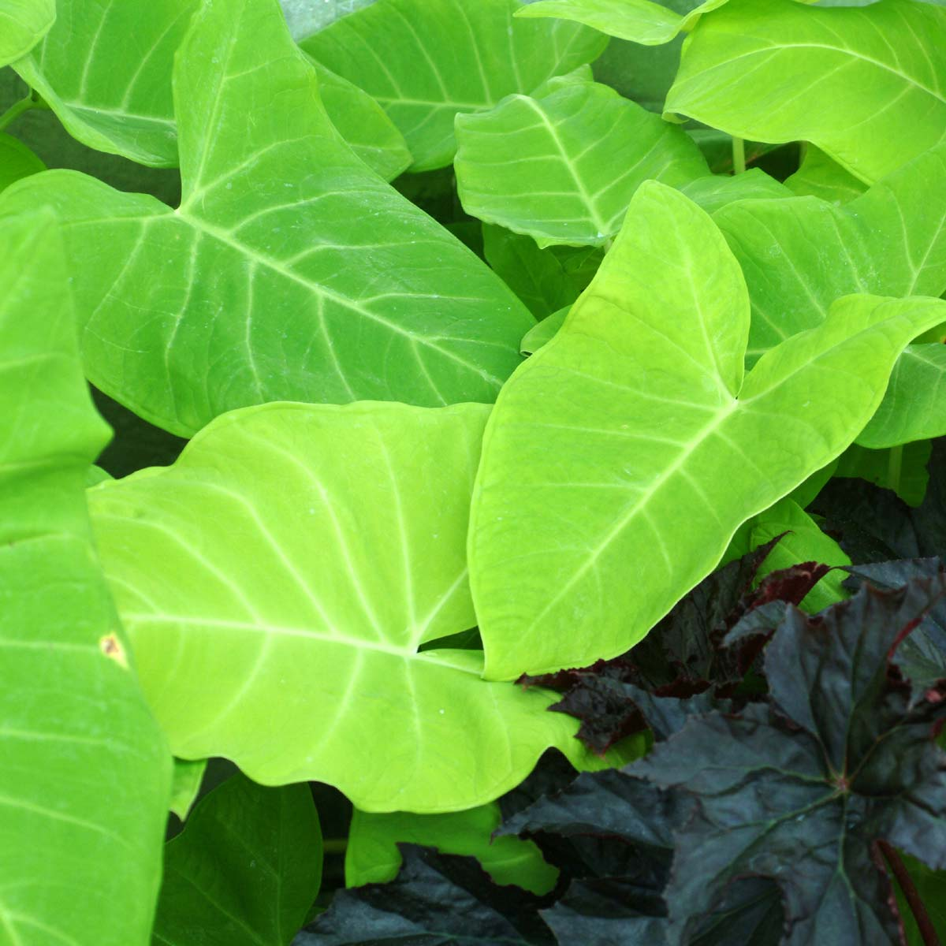
It is easy to find pretty plants with a bad reputation, and equally likely to find a plant with an undeserved bed reputation. You have now met the poster child for the misunderstood plant.
Xanthosoma are related to Philodendron but NOT TO BE CONFUSED with Colocasia and Alocasia which are extremely invasive genera depending in where you garden. Aquatic weeds these cousins overshadow most of the family for over running native wetlands and making a mess, BUT not Xanthosoma! These are mostly very tropical, so cold sensitive and have beautifully marked and colored foliage.
Other common names they are confused and mixed up with: Caladium, Dasheen, Elephant Ears, Green Taro, Malanga Taro, Yam, Cocoyam, Ubi Keladi, Eddoe, and Alocasia.
Culture and Care
Where to plant?
- Exposure: These plants will grow in full sun but will appreciate some afternoon shade, or very light shade in our scorching summers.
- Watering: They love water, they do not need to be IN water only that they like consistent moisture, places where the soil generally stays moist, and they do not get dried out or scorched. Because their leaves grow quite large, they are very architectural. Large pots are also a good way to highlight the plants.
Care & Maintenance.
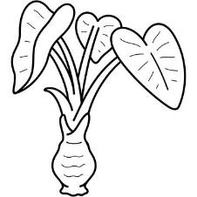
- Fertilizing: They really don’t need fertilizer and are adapted to growing in Florida soils, so if you want to you can fertilize with any general tree and shrub fertilizer. The more water and the more fertilizer you apply the faster, larger and lusher they grow.
- Pruning: Since the tubers multiply at or just below the soil line it is easy to just pull unwanted plants by hand or with a shovel or pitchfork. Whenever a clump becomes crowded a quick dig or pitchfork to remove old tuber will easily reduced the plants back to manageable numbers.
History etc.
- Origin: Most Alocasias come from Latin America (the nastier invasive ‘generally’ come from SE Asia. Many have starchy edible tubers and many are mildly toxic especially if eaten raw. It is smart to learn the difference.
- Winter Hardiness: Hardy, semi-hardy and sensitive form all grow in central north Florida. The only was to know about what works in your garden, but for best results get plants plant into spring and established before fall for stronger survival.
Others beauties you my come across:
- Xanthosoma lindenii, Xanthosoma violaceum, Xanthosoma sagittifolium ' Variegatum Monstrosum’ (aka Mickey Mouse’).

